Moroccan Lentil Soup
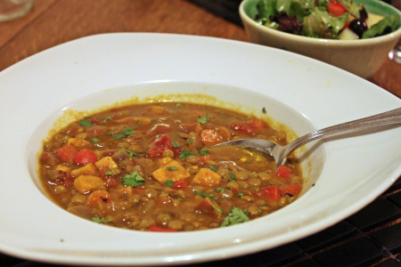

Freezer Package Ingredients:
1 ¾ c red lentils
2 c chopped onions
2 c chopped carrots
3 c chopped cauliflower
4 cloves garlic minced
1 can (28 oz) diced tomatoes
2 T tomato paste
2 T lemon juice
1 tsp cumin
1 tsp ground coriander
1 tsp ground turmeric
¼ tsp ground cinnamon
¼ tsp ground pepper

Other Ingredients:
6 cups meat or vegetable broth
2 cups water
4 c fresh spinach (10 oz bag or equivalent frozen)
½ c fresh cilantro
dash of olive oil
Add broth, water and freezer package to a large pot. Cook, stirring occasionally to separate frozen chunks for 45-55 minutes, add spinach the last 15 minutes, stir in a little olive oil for flavor at end of cooking, garnish with cilantro. The cilantro can be added to freezer package instead, for convenience.

