Stir Fry Vegetables x 2
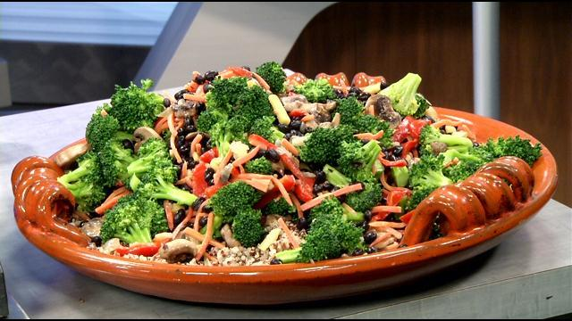
Freezer Package Ingredients:
½ c broccoli chopped coarsely 2 carrots sliced thinly at an angle
1 medium onion, sliced thinly ½ c bok choy leaf and stem, chopped
1 red bell pepper, stem and seeds removed ; chopped coarsely
4-6 oz mushrooms quartered

Other Ingredients:
1 c quinoa, pre-cooked
2 T coconut oil
2 T balsamic vinegar
Sea salt and pepper
Melt coconut oil in pan, add all vegetables and cook over med high heat for 3-5 minutes until vegetables are slightly softened. Add vinegar and seasonings to taste. Serve immediately on top of quinoa. Serves 4

