Spinach Vegetable Soup
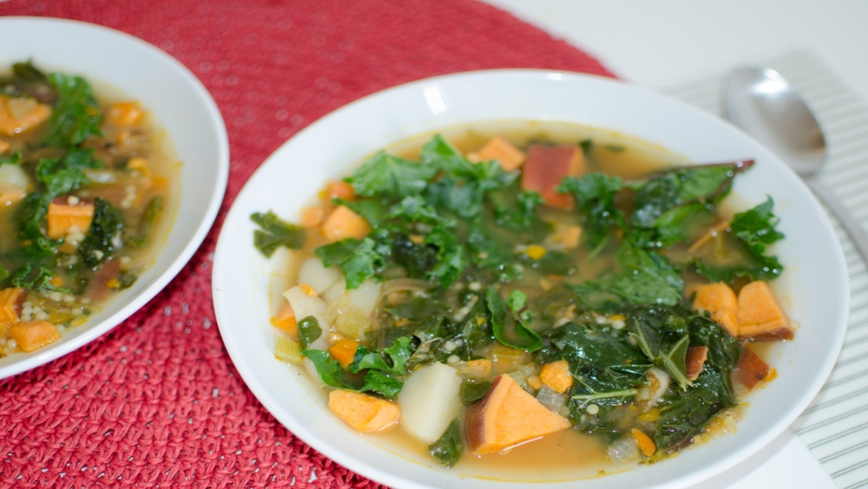
Freezer Package Ingredients:
1 small onion, chopped
1 medium sweet potato, peeled and chopped
4 oz fresh baby spinach,(Can substitute Kale or Swiss Chard)
2 stalks celery, chopped
2 carrots, chopped
1 clove garlic, peeled, smashed/chopped
Other Ingredients:
1 T olive oil
4 c meat or vegetable broth (pre-made, or bought organic)

Sauté vegetables in oil for 5 minutes, a bit longer if frozen. Do not brown. Add broth and bring to a boil. Cook for ~ 10 minutes. Reduce heat. Season soup with salt and pepper to taste. Serves 2-4

